**Question 1.**

**Solution:**

Write a summary report with your observations and conclusions.

After increment in data, The Algo 1 increases rapidly but not as much as Algo 2. While, In Algo 3 and Algo 4 there are no any noticeable changes.

**Question:2**

**Solution:**

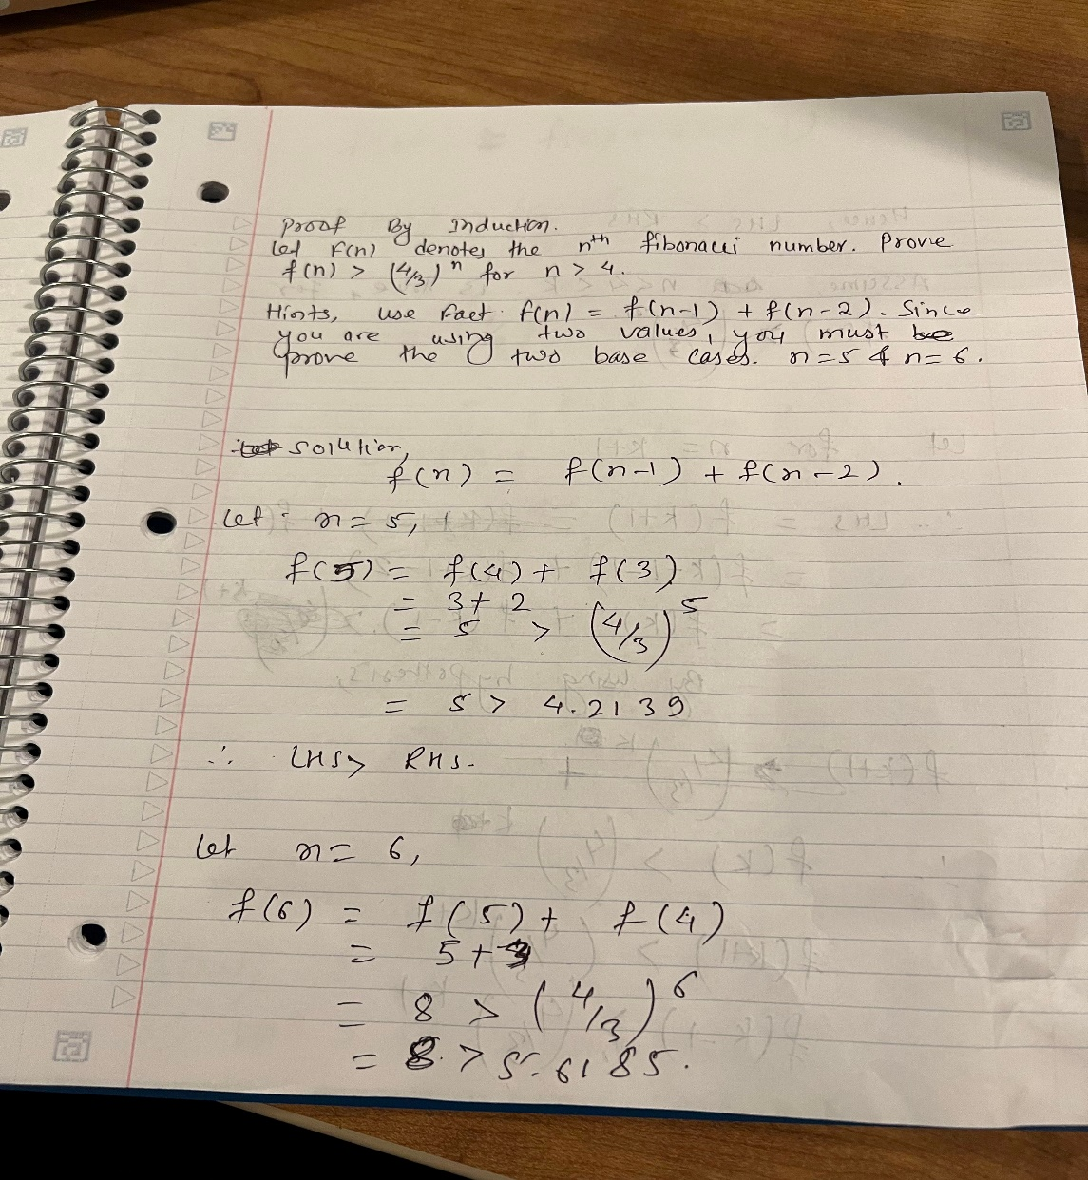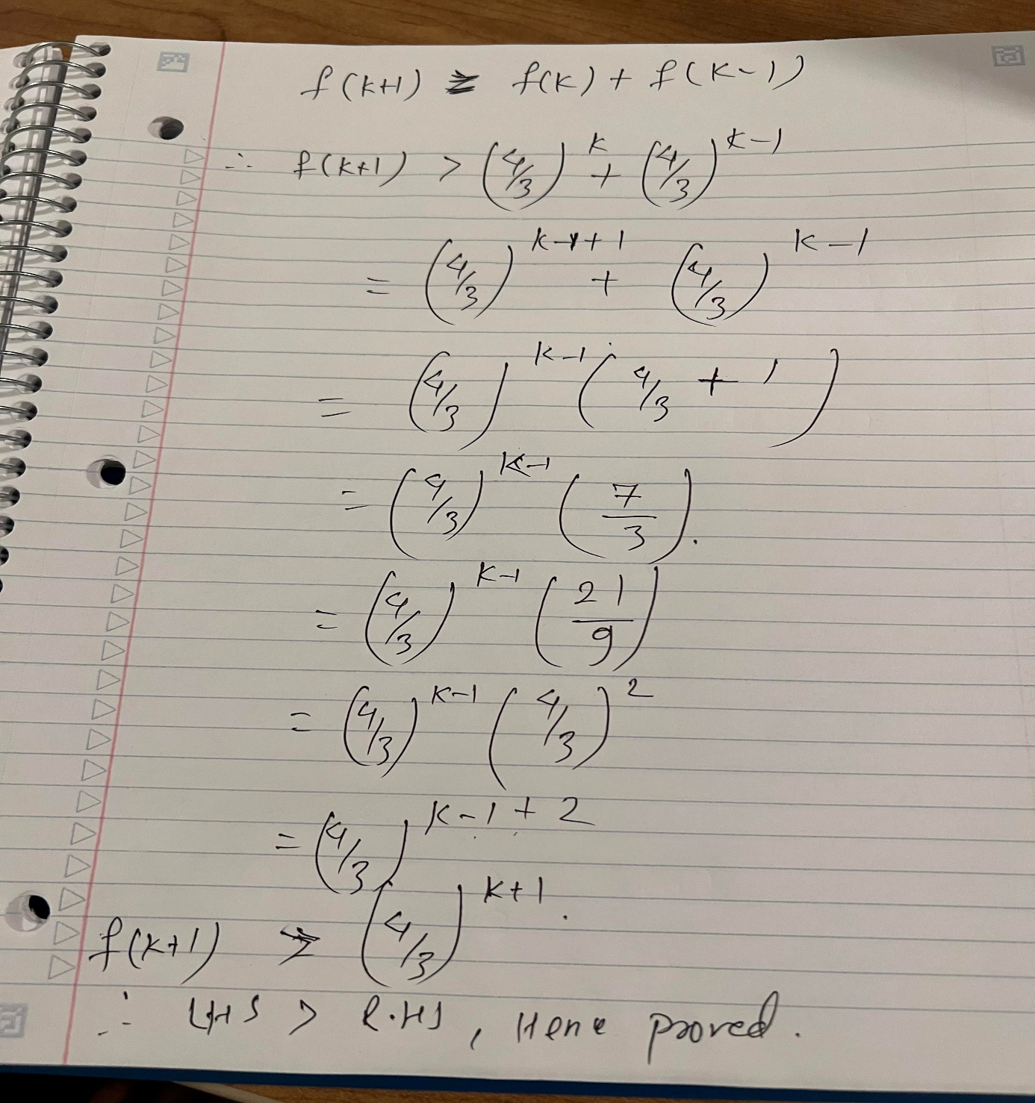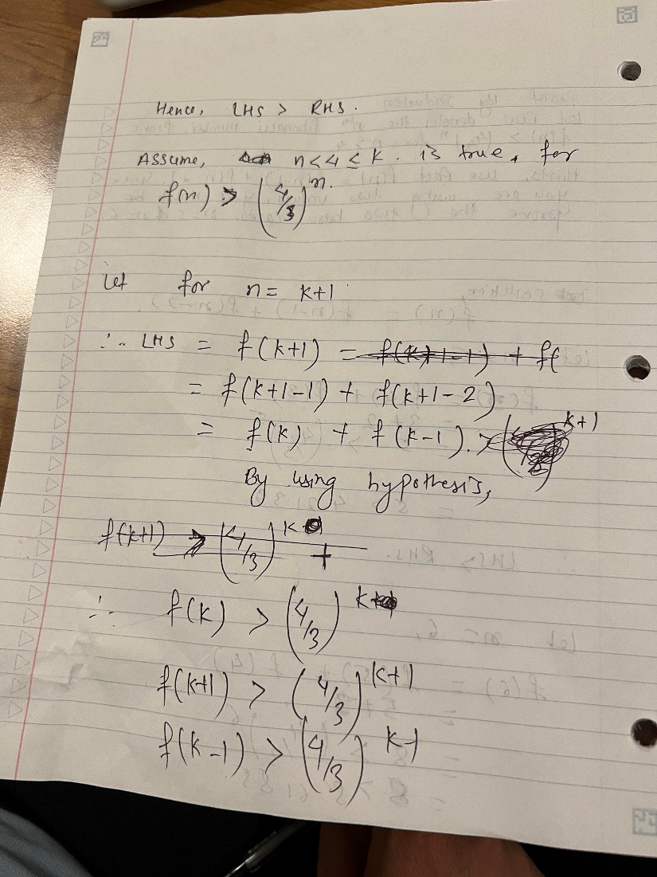

Team Member:

Binod Pant (614654)

Jenish Ghimire (614700)

Sanjaya Koju (614759)